Multi-Algorithm Recommendation System Comparison
E-Commerce Rating Prediction, Purchase Prediction & Customer Segmentation
Mini Project 3 — Machine Learning Comparison Report
Prepared using Python, Pandas, NumPy, Scikit-learn, Matplotlib and Seaborn.

1. Problem Statement
E-commerce platforms need to recommend the right products to the right customers. A single machine learning technique cannot address every part of this problem, so this project combines three complementary approaches: regression to estimate how a customer will rate a product, classification to predict whether a customer will purchase a product, and clustering to group customers by behavior. Comparing these approaches shows which technique is most useful for which business decision.

2. Dataset Description
A synthetic e-commerce interaction dataset was generated (no production dataset was supplied) with 6,040 rows and 10 columns, following the schema requested in the brief: User ID, Product ID, Product Category, Rating, Price, Purchase Status, Number of Views, Cart Status, Time Spent, and Previous Purchases. The data was generated with realistic dependencies — for example, higher cart activity and time on page increase the probability of both a higher rating and an eventual purchase — so the models have genuine signal to learn, similar to what would be found in real clickstream and transaction data.

2.1 Raw Data Quality
Check | Result
Rows × Columns (raw) | 6040 × 10
Duplicate records found | 40
Missing values — Rating | 60
Missing values — Time Spent | 120
Rows × Columns (after cleaning) | 6000 × 10

3. Data Preprocessing
- Removed 40 duplicate records identified via full-row comparison.
- Filled missing Rating values with the column median (rating is discrete 1–5).
- Filled missing Time Spent values with the column median.
- One-hot encoded the Product Category column (drop-first to avoid the dummy-variable trap).
- Standardized numeric features with StandardScaler before Ridge Regression, Logistic Regression, and K-Means, since all three are distance/gradient-sensitive.
- Split the data 80% training / 20% testing for the regression and classification tasks, using stratified sampling for classification to preserve the purchase/no-purchase ratio.

4. Regression Model — Predicting Product Rating
Ridge Regression was trained to predict the Rating a user is likely to give a product, using price, browsing behavior, and purchase-history features as inputs. Ridge was preferred over plain Linear Regression because its L2 penalty controls overfitting once the one-hot encoded category columns are added.

4.1 Hyperparameter Tuning
GridSearchCV (5-fold cross-validation, scoring = negative MAE) searched alpha ∈ {0.01, 0.1, 1, 10, 100}. Best alpha found: 0.01.

4.2 Results: Baseline vs Tuned
Metric | Baseline (alpha=1.0) | Tuned (GridSearchCV)
MAE | 0.551 | 0.551
RMSE | 0.666 | 0.666
R² Score | 0.123 | 0.123
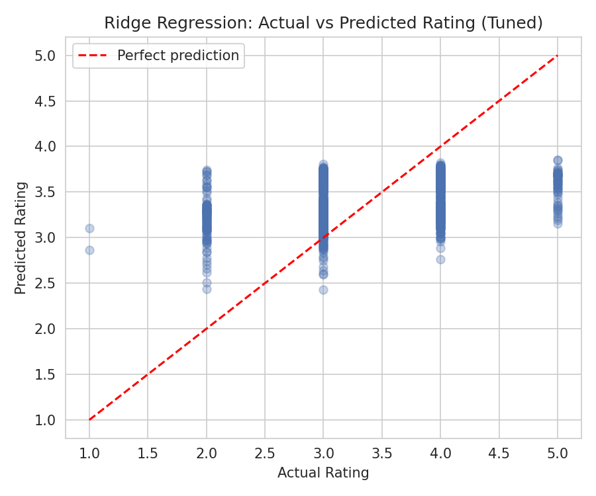
The model explains a modest share of the variance in ratings (R² ≈ 0.12), meaning the available behavioral features capture some — but not most — of what drives a rating. This is realistic: ratings are also influenced by product quality and subjective taste, which aren't present in clickstream-style data. The MAE of roughly 0.55 stars indicates predictions are, on average, close to the true rating on the 1–5 scale.

5. Classification Model — Predicting Purchase Likelihood
Logistic Regression was trained to predict Purchase Status (1 = purchased, 0 = not purchased) from browsing and engagement features, including cart status and rating.

5.1 Hyperparameter Tuning
GridSearchCV (5-fold cross-validation, scoring = F1) searched C ∈ {0.01, 0.1, 1, 10}, solver ∈ {liblinear, lbfgs}, and max_iter ∈ {100, 200, 500}. Best parameters found: C = 1, solver = liblinear, max_iter = 100.

5.2 Results: Baseline vs Tuned
Metric | Baseline (default) | Tuned (GridSearchCV)
Accuracy | 0.762 | 0.762
Precision | 0.534 | 0.538
Recall | 0.214 | 0.218
F1 Score | 0.306 | 0.310
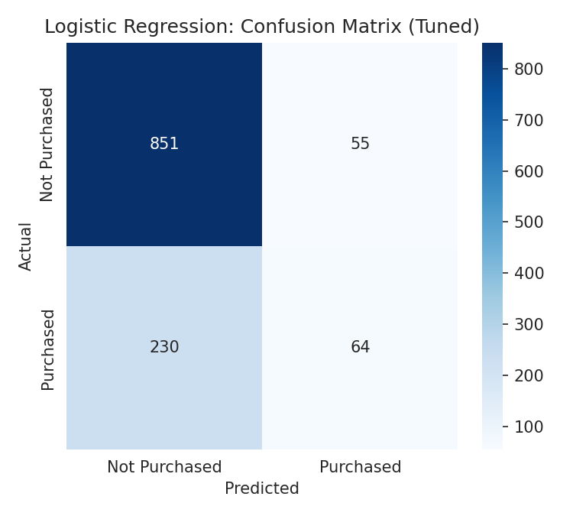
The confusion matrix shows 64 true positives (correctly identified purchasers) against 230 false negatives (missed purchasers) and 55 false positives. Accuracy (~76%) is inflated by the class imbalance — most visits do not end in a purchase — so precision and recall are more informative here. Recall (~22%) shows the model is conservative: it correctly flags purchasers, but misses a substantial number of them. For a marketing use case, this trade-off (high precision, lower recall) means the model is better suited to a "confident targeting" list than a broad "catch every buyer" list.

6. Clustering Model — Customer Segmentation
K-Means was applied to customer-level aggregated features (total views, total purchases, average rating given, average time spent, total amount spent, and cart additions) to group customers by behavior.

6.1 Choosing the Number of Clusters
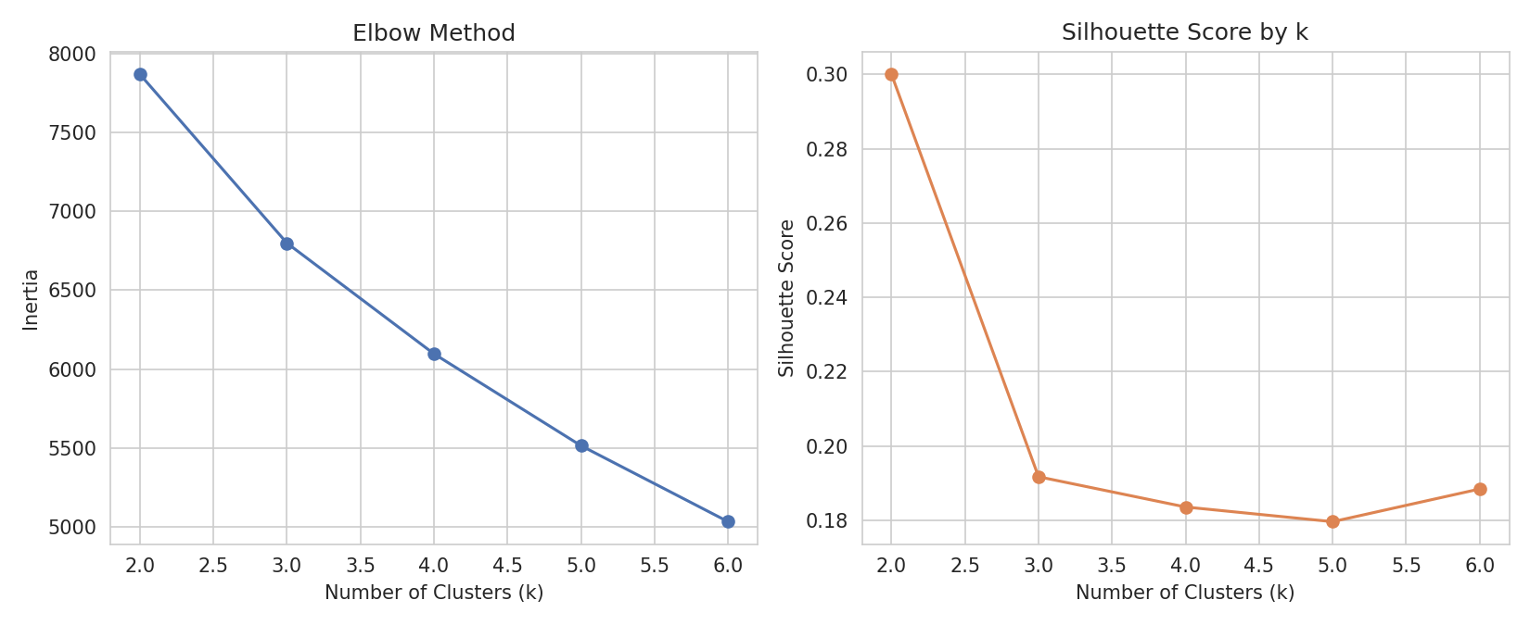
k | Inertia | Silhouette Score
2 | 7870.6 | 0.300
3 | 6799.3 | 0.192
4 | 6096.6 | 0.184
5 | 5513.6 | 0.180
6 | 5031.5 | 0.188
The silhouette score peaks at k = 2 (score ≈ 0.300), indicating the clearest separation is a two-group split between low-engagement and high-engagement customers. In practice, a business team may still choose a slightly higher k (e.g., 4) to get more actionable segments for marketing, accepting a small drop in silhouette score in exchange for more nuanced groups — this is a modeling judgment call worth discussing with stakeholders.

6.2 Cluster Profiles
Cluster | Avg Views | Avg Purchases | Avg Rating | Avg Time Spent (min) | Total Spend | Avg Cart Adds
Cluster 0 | 17.61 | 0.35 | 3.35 | 3.68 | 7.92 | 0.95
Cluster 1 | 32.94 | 1.75 | 3.49 | 3.97 | 56.92 | 2.62
Cluster | Number of Customers
Cluster 0 | 1304
Cluster 1 | 581
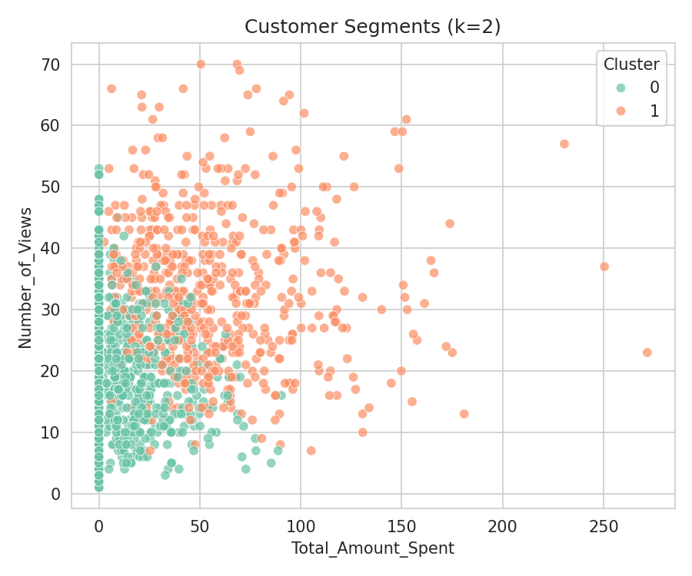
Cluster 1 represents a smaller group of highly engaged, higher-spending customers (more views, more purchases, higher total spend, more cart activity). Cluster 0 represents the larger group of lower-engagement, mostly browsing customers. This maps naturally to the 'high-value customers' vs 'window shoppers' segments described in the brief.

7. Model Comparison Table
ML Task | Algorithm | Target / Goal | Metrics Used | Best Result | Business Use
Regression | Ridge Regression | Predict product rating | MAE, RMSE, R² | MAE 0.55, R² 0.12 | Recommend highly-rated products
Classification | Logistic Regression | Predict purchase likelihood | Accuracy, Precision, Recall, F1 | F1 0.31, Acc 0.76 | Target likely buyers with offers
Clustering | K-Means | Segment customers | Inertia, Silhouette | k=2, Silhouette 0.30 | Create tailored customer groups

8. Business Interpretation

8.1 Which model performs 'better'?
The three models are not directly comparable on a single scale because they answer different business questions — but each can be judged against the difficulty of its own task.
- Regression (Ridge): Explains a modest portion of rating variance (R² ≈ 0.12). Useful as one signal among several for ranking products, but should not be the sole basis for recommendations.
- Classification (Logistic Regression): Reasonable precision (~54%) but limited recall (~22%) for identifying purchasers. Most reliable when used to build a short, high-confidence target list rather than a broad campaign.
- Clustering (K-Means): Produces a clean, well-separated 2-segment split (silhouette ≈ 0.30) distinguishing high-value customers from low-engagement browsers — the most immediately actionable output for marketing segmentation.

8.2 Recommended usage
For this dataset, clustering delivers the clearest, most directly actionable business insight (who to target differently), while classification is best used narrowly for high-confidence purchase-intent targeting, and regression is best used as a supporting signal inside a broader recommendation ranking rather than a standalone prediction.

9. Final Conclusion
This project demonstrates that no single machine learning technique is sufficient for a full e-commerce recommendation system. Regression, classification, and clustering each address a distinct business question — what rating to expect, who is likely to buy, and how to group customers — and together they form a more complete decision-support system than any one model alone. Hyperparameter tuning with GridSearchCV produced small but consistent improvements across the regression and classification models, and the elbow/silhouette analysis gave a data-driven basis for choosing the number of customer segments. Future improvements could include richer behavioral history, collaborative-filtering signals, and non-linear models (e.g., gradient boosting) to raise predictive performance further.

10. Appendix — Tools & Libraries
Tool / Library | Usage
Python | Main programming language
Pandas | Data loading and preprocessing
NumPy | Numerical operations
Matplotlib / Seaborn | Data visualization
Scikit-learn | Models, GridSearchCV, evaluation metrics

